1/4/2023

DEDOC

Applying Federated Learning with Smart Contracts in Health Care

GROUP MEMBERS:

S SARMAD JAMAL 19K-1116

MUHAMMAD KHIZER JILANI 19K-1057

MANSOOR BUTT 19K-1114

|  |  |  |  |  |  |  |  |  |  |  |  |  |
| --- | --- | --- | --- | --- | --- | --- | --- | --- | --- | --- | --- | --- |
| **Software Requirement Specifications**  **Applying Federated Learning using Smart Contracts in Healthcare (DEDOC)**    **Version: 1.0**   |  |  | | --- | --- | | **Project Code** |  | | **Supervisor** | Dr Farrukh Shahid | | **Co Supervisor** | Shahbaz Siddiqui | |  |  | | **Project Team** | Sarmad Jamal (k191116)  Mansoor Butt (k191114)  Muhammad Khizer Jilani (k191057) | | **Submission Date** | 25-11-2022 | |

Document History

|  |  |  |  |
| --- | --- | --- | --- |
| **Version** | **Name of Person** | **Date** | **Description of change** |
| 0.1 | Whole team | 27-Oct | Introduction |
| 0.2-0.9 | Whole team | 28-Oct | Need to be complete by Sarmad |
| 1.0 | Whole team | 30-Oct | Finalized |
|  |  |  |  |
|  |  |  |  |
|  |  |  |  |
|  |  |  |  |

Distribution List

|  |  |  |
| --- | --- | --- |
| **Name** | **Role** | |
| DR FARRUKH SHAHID | | Supervisor |
| SHAHBAZ SIDDIQUI | | Co- Supervisor |
|  | |  |

**Document Sign-Off**

|  |  |  |
| --- | --- | --- |
| **Version** | **Sign-off Authority** | **Sign-off Date** |
| 1.0 | Supervisor | 25-Nov |
| 1.0 | Co-Supervisor | 25-Nov |
| 1.0 | Jury | TBD |

**Table of Contents**

Table of Contents

[**1** **Introduction** 4](#_Toc120312999)

[**1.1** Purpose of Document 4](#_Toc120313000)

[**1.2** Intended Audience 4](#_Toc120313001)

[**1.3** Abbreviation 4](#_Toc120313002)

[**1.4** Document Convention 4](#_Toc120313003)

[**2** **Overall System Description** 5](#_Toc120313004)

[**2.1** Project Background 5](#_Toc120313005)

[**2.2** Project Scope 5](#_Toc120313006)

[**2.3** Not In Scope 5](#_Toc120313007)

[**2.4** Project Objectives 6](#_Toc120313008)

[**2.5** Stakeholders 6](#_Toc120313009)

[**2.6** Operating Environment 6](#_Toc120313010)

[**2.7** System Constraints 7](#_Toc120313011)

[**2.8** Assumption & Dependency 7](#_Toc120313012)

[**3** **External Interface Requirements** 7](#_Toc120313013)

[**3.1** Hardware Interface 7](#_Toc120313014)

[**3.2** Software Interface 7](#_Toc120313015)

[**3.3** Communications Interfaces 8](#_Toc120313016)

[**4** **Functional Requirements** 8](#_Toc120313017)

[4.1 Functional Hierarchy 8](#_Toc120313018)

[The super Admin and providers have a specific identity number that identifies their account. The account is accessed via a special account address of web3 provider such as meta mask and for another way of authentication we will use firebase to authenticate the data 8](#_Toc120313019)

[**4.2** Use Cases 9](#_Toc120313020)

[**4.2.1** Form Submission 9](#_Toc120313021)

[**4.2.2** Hospital/Superuser Use Case 11](#_Toc120313022)

[**5** **Non-Functional Requirements** 12](#_Toc120313023)

[**5.1** Performance Requirement 12](#_Toc120313024)

[**5.2** Safety Requirement 12](#_Toc120313025)

[**5.3** Security Requirement 12](#_Toc120313026)

[Data Transfer 12](#_Toc120313027)

[Data Storage 13](#_Toc120313028)

[**5.4** User Documentation 13](#_Toc120313029)

[**6** References 13](#_Toc120313030)

[**7** Appendices **Error! Bookmark not defined.**](#_Toc120313031)

# **Introduction**

## Purpose of Document

The purpose of the document is to collect and analyse all assorted ideas that have come up to define the system, its requirements with respect to consumers. Also, we shall predict and sort out how we hope this product will be used in order to gain a better understanding of the project, outline concepts that may be developed later, and document ideas that are being considered, but may be discarded as the product develops. In short, the purpose of this SRS document is to provide a detailed overview of our software product, its parameters and goals. This document describes the project's target audience and its user interface, hardware and software requirements.

## Intended Audience

The purpose of this document is to give a detailed description of the requirements for our Final year Project. It will illustrate the purpose, scope and complete description for the development of system. It will also explain external interface requirements and system requirements as well as non-functional requirements. This document is primarily intended to be proposed to a customer for its approval and also for further processing such as additions to be developed in later releases. Customers/hospitals can refer to section 3 and 4 for the list of requirements implemented in Version final. This document will also be used as a reference for developing and testing Version final

## Abbreviation

|  |  |
| --- | --- |
| FAQ | Frequently Asked Questions |
| EHR | Electronic health care Records |
|  |  |

## Document Convention

Throughout this document, All the user entities are written in capitalizations i.e., first

letter as capital. Also, any significant term which has been described in the glossary is

made bold and italic in the text. On the other hand, those terms which are significant (but

not described in glossary) are bold in text. The document is prepared using Microsoft Word 2020 and has used the font type 'Times New Roman'. The fixed font size that has been used to type this document is 12pt and for headings 14pt with 1 linespacing

# **Overall System Description**

## Project Background

Blockchain is also used in the healthcare management system for effective maintenance of electronic health and medical records. The technology ensures security, privacy, and immutability. This work proposes a framework by integrating the blockchain and Federated Deep Learning in order to provide a tailored recommendation system. Electronic medical records contain personal and confidential information that traditional storage methods must protect against cyberattacks and third-party authentication. To overcome this challenge, a method of distributed storage was proposed in this work. The focus of this work is also on making treatment recommendations to patients by comparing their medical records with historical data. This work is motivated by the limitations of existing work. The current study supports his EHR preservation, but the recommendation system is neither discussed nor incorporated, making it difficult to create a treatment recommendation system. Federated learning may therefore lead to more accurate treatment recommendations.

## Project Scope

Primarily, the scope of our final year project is limited. We will be limiting our scope to the medical sectors where a patient data will be recorded on our system and by means of recording, we will be using that data only to train our machine learning model. We will be using the concept of federated Learning Through Federated learning, multiple organizations or institutions work together to solve a machine-learning problem under the coordination of a central server or service provide. Thus, a deep-learning model is maintained and improved upon within a central server. The model is trained by distributing itself to hospitals which allows these sites to keep their data localized. Data from each collaborator is never exchanged or transferred during training. Instead of bringing the data to the central server, as in conventional deep learning, the central server maintains a global shared model, which is disseminated to all institutions. Each entity subsequently maintains a separate model based on its own patients’ data. Thereafter, each center provides feedback to the server based on its individually trained model—either by its weight or the error gradient of the model. The central server aggregates the feedback from all participants, and based on predefined criteria, updates the global model. The predefined criteria allow the model to evaluate the quality of the feedback and therefore to only incorporate that which is value-adding. The feedback from centers with adverse or strange results can thus be ignored. This process forms one round of federated learning, and it is iterated until the global model is trained.

## Not In Scope

We will be only targeting one/two disease for the recommendation and it will be running on local environment not globally deployed. It will be on private blockchain and only people who are connected will have the feasibility to connect to it

## Project Objectives

Our system implementation addresses the three major issues:

1. slow access to medical data
2. system interoperability
3. patient agency

Recent advances in deep learning have shown many successful stories in smart healthcare applications with data-driven insight into improving clinical institutions’ quality of care. Excellent deep learning models are heavily data-driven. The more data trained, the more robust and more generalizable the performance of the deep learning model. However, pooling the medical data into centralized storage to train a robust deep learning model faces privacy, ownership, and strict regulation challenges. **Federated learning** resolves the previous challenges with a shared global deep learning model using a central aggregator server. At the same time, patient data remain with the local party, maintaining data anonymity and security.

This method provides decentralized machine learning model training with-out transmitting medical data through a coordinated central aggregate server. Medical institutions, working as client nodes, train their deep learning models locally and then periodically forward them to the aggregate server. The central server coordinates and aggregates the local models from each node to create a global model, then distributes the global model to all the other nodes. It is worth noting that the training data are kept private to each node and never transmitted during the training process. Only the model’s weight and parameters are transmitted, ensuring that medical data remain conﬁdential. For these reasons, FL mitigates many security concerns because it retains sensitive and private data while enabling multiple medical institutions to work together. FL holds an excellent promise in healthcare applications to improve medical services for both institutions and patients—for instance, predict autism spectrum disorder, mortality and intensive care unit (ICU) stay-time prediction.

## Stakeholders

Users that will be interacting with our system will be the hospital admin, a super admin and a patient for the development purpose the development team along with the QA team will be responsible for the working of the system and they’ll be the one interacting with the system. Stakeholders can only take actions according to the roles providing to them

## Operating Environment

It is a web-based application running on a browser and since it is locally deployed. Only the user with the accessibility can access the system. The user must have a node js version of > 14.00. Ganache should be installed on the system and a web3 provider such as meta mask should be installed on the browser in order to authenticate the system

## System Constraints

* **Software constraints**

Node js version above 14.00 for running js locally. Ganache along with meta mask extension should be installed on the system

* **Hardware constraints**

No such constraints for hardware

* **Cultural constraints**

Understanding of English language since all the instructions are provided in English, so we’re guessing that our end user should have a good grip on English.

## Assumption & Dependency

One assumption about the software is that it will always be used on system that have enough resources to run the application. If the system does not have enough hardware resources available for the application, there may be scenarios where the application does not work as intended or not even at all. The application uses IPFS for online storage of information. If the interface changes the application needs to be adjusted accordingly. External libraries of web3 and ether js should be installed on the system along with the JavaScript, so it should be run smoothly

# **External Interface Requirements**

## Hardware Interface

Since the application must run over the internet, all the hardware shall require to connect internet will be hardware interface for the system. As for e.g., Modem, WAN – LAN, Ethernet Cross-Cable.

## Software Interface

**Operating System**: We have chosen Windows operating system for its best support and user-friendliness.

**Database**: To save the data of model in an IPFS distributed database system.

**Smart Contracts**: To save and implement the contract which is agreed between two entities in the system

**Ethereum Blockchain**: Ethereum Blockchain used to ensure smoothness of program and decentralization of system

**Global Server**: Global server used to interact with the hospital server to send/receive the training model

## Communications Interfaces

The DEDOC system shall use the HTTP protocol for communication over the internet and for the intranet communication will be through TCP/IP protocol suite.

# **Functional Requirements**

## Functional Hierarchy

## The super Admin and providers have a specific identity number that identifies their account. The account is accessed via a special account address of web3 provider such as meta mask and for another way of authentication we will use firebase to authenticate the data

As data will be generated from multiple organizations, data must be accessible and consistent at all times. The integrity of the data must not be compromised.

**Features**

We have Implemented a user-friendly application user interface using React Js technology. It provides an interactive and responsive UI with adequate performance. The navigation from one page to another is explicitly shown.

The project included the following features with respect to super admin and providers (Healthcare institutions).

Login: Login page for super Admin and provider

Signup: Signup page for provider

functionalities related to provider

View Form: Doctor can view patient available respective data

Fill form: Receptionist will submit the form of the patient

Request a particular doctor: Receptionist can request a particular doctor

Take part in training: provider will have a functionality to train its model

functionalities related to super Admin

Retrieve model: super Admin can retrieve hospital model and make it interact with the global model

Aggregation of model: super admin will aggregate the model based on the weights of the different models

## Use Cases

## Form Submission

[Use Case Diagram]

*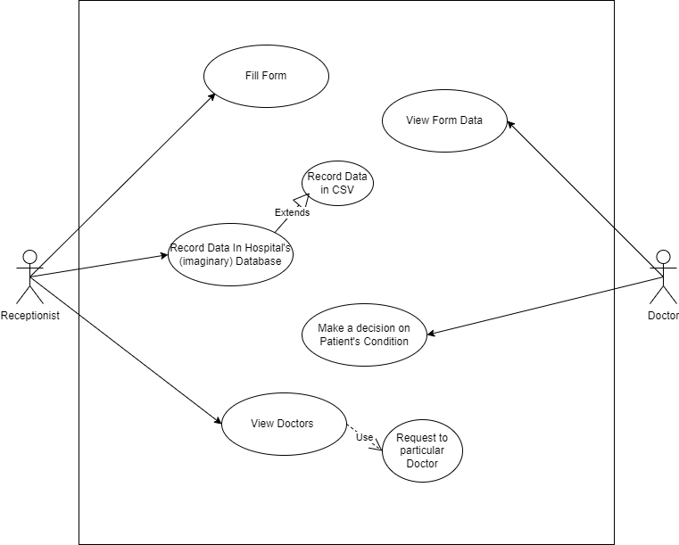*

|  |  |  |  |  |
| --- | --- | --- | --- | --- |
| **Form Submission** | | | | |
| **Use case Id:** | | 1 | | |
| **Actors:**  Receptionist, Doctor | | | | |
| **Feature:** Submission of form | | | | |
| **Pre-condition:** | | Receptionist must be logged in and have a list of doctors  Doctor should be authenticated and have a verified account given by the provider | | |
| **Scenarios** | | | | |
| **Step#** | **Action** | | | **Software Reaction** |
| **1.** | Fill the form of the patient | | | Fill input fields provided on the user interface and submit it |
| **2.** | Doctor will make a decision on the given form data and patient condition | | | A form view option will be visible to the doctor and he can view the patient data on the form and will make a decision accordingly for the treatment |
|  |  | | |  |
| **Alternate Scenarios:** | | | | |
| **None** | | | | |
| **Post Conditions** | | | | |
| **Step#** | **Description** | | | |
| **1** | A final decision for the patient treatment will be taken and if the patient agrees to take part in training aggregate weights will be updated on the global server | | | |
|  |  | | | |
|  |  | | | |
| **Use Case Cross referenced** | | | None | |

## Hospital/Superuser Use Case

*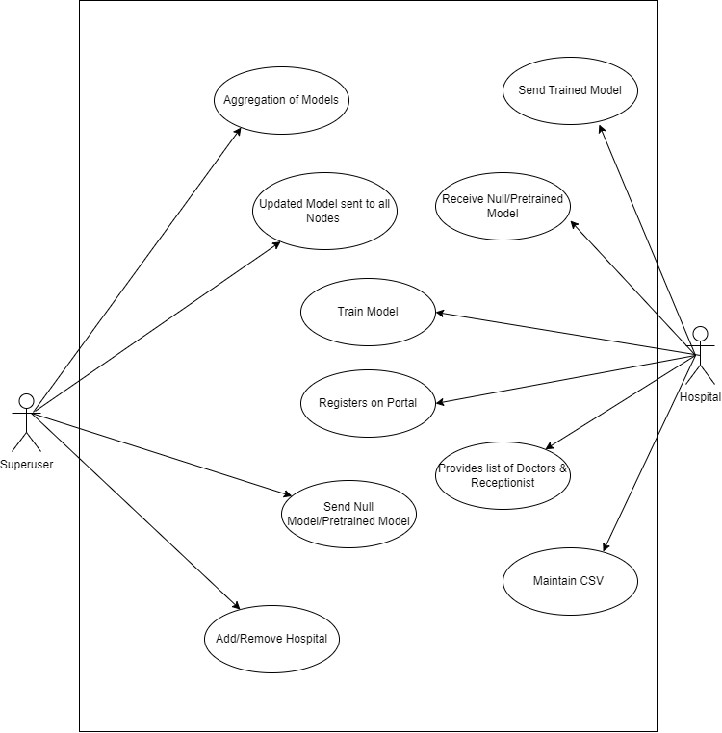*

[Use Case Description]

|  |  |  |  |  |
| --- | --- | --- | --- | --- |
| **Model training** | | | | |
| **Use case Id:** | | 2 | | |
| **Actors:**  Super User,Hospital | | | | |
| **Feature:** Training of Model | | | | |
| **Pre-condition:** | | SuperUser must be logged in and have access to global server model and have weights passed to it by the hospital | | |
| **Scenarios** | | | | |
| **Step#** | **Action** | | | **Software Reaction** |
| **1.** | Hospital will register itself on the portal | | | Hospital will get access to take part in training of model and interacting with our system |
| **2.** | Superuser can add or remove provider from the system | | | Hospitals with the penalty charges or the hospital which are sucessfully registered will act accordingly |
|  |  | | |  |
| **Alternate Scenarios:** | | | | |
| **None** | | | | |
| **Post Conditions** | | | | |
| **Step#** | **Description** | | | |
| **1** | Trained model on the recent data will be passed to the hospital and all the nodes will be updated | | | |
|  |  | | | |
|  |  | | | |
| **Use Case Cross referenced** | | | 1 | |

# **Non-Functional Requirements**

## Performance Requirement

5 seconds.

NFR01-05 System must successfully run on a client machine with 256 MB RAM or above

The System shall be based on web and has to be run from a web server. The system shall take initial load time depending on internet connection strength which also depends on the media from which the product is run. The performance shall depend upon hardware components of the client/customer

## Safety Requirement

The software is completely environmentally friendly and does not cause any safety violations. The web page will have a flexible font that can be zoomed so as to not over constrain the eyes.

## Security Requirement

### Data Transfer

* The system shall use secure sockets in all transactions that include any confidential customer information.
* The system shall automatically log out all customers after a period of inactivity.
* The system shall confirm all transactions with the customer’s web browser.
* The system shall not leave any cookies on the customer’s computer containing the user’s password.
* The system shall not leave any cookies on the customer’s computer containing any of the user’s confidential information.

### Data Storage

* The customer’s web browser shall never display a customer’s password. It shall always be echoed with special characters representing typed characters.
* The customer’s web browser shall never display a customer’s credit card number after retrieving from the database. It shall always be shown with just the last 4 digits of the credit card number.
* The system’s back-end servers shall never display a customer’s password. The customer’s password may be reset but never shown.
* The system’s back-end servers shall only be accessible to authenticated administrators.
* The system’s back-end databases shall be encrypted.

## User Documentation

The software is accompanied by the following materials for further help:

● Software Requirement Document

● Software Design Specification Document

## References

1. R. Roth, [M, Sheller](https://www.nature.com/articles/s41746-020-00323-1#auth-Micah-Sheller), “The future of digital health with federated

learning

”, September 2022, online: “<https://www.nature.com/articles/s41746-020-00323-1>”.

1. R. Stoffel et al,” Federated Learning for Healthcare: Systematic
2. Review and Architecture Proposal”, august 2022, online: ”<https://dl.acm.org/doi/10.1145/3501813>”
3. J.Xiu,C.Su,P.Walker, ”Federated Learning for Healthcare

Informatics”, November 2020, online: “[https://link.springer.com/article/10.1007/s41666-020-00082-4”](https://link.springer.com/article/10.1007/s41666-020-00082-4)

|  |  |  |  |  |  |  |  |  |  |  |  |  |  |  |  |  |  |  |  |  |  |  |  |  |  |  |  |  |  |  |  |  |  |  |  |  |  |  |  |  |  |  |  |  |  |  |  |  |  |  |  |  |  |  |  |  |  |  |  |  |  |  |  |
| --- | --- | --- | --- | --- | --- | --- | --- | --- | --- | --- | --- | --- | --- | --- | --- | --- | --- | --- | --- | --- | --- | --- | --- | --- | --- | --- | --- | --- | --- | --- | --- | --- | --- | --- | --- | --- | --- | --- | --- | --- | --- | --- | --- | --- | --- | --- | --- | --- | --- | --- | --- | --- | --- | --- | --- | --- | --- | --- | --- | --- | --- | --- | --- |
| |  |  |  |  |  |  |  |  |  |  |  | | --- | --- | --- | --- | --- | --- | --- | --- | --- | --- | --- | | **Software Design Specifications**  **Applying Federated Learning using Smart Contracts in Healthcare (DEDOC)**  **Version: 1.0**   |  |  | | --- | --- | | **Project Code** | F22-3006 | | **Supervisor** | DR FARRUKH SHAHID | | **Co Supervisor** | SHAHBAZ SIDDIQUI | | **Project Team** | Mansoor Butt (19K-1114)    Muhammad Khizer Jilani (19K-1057)  Sarmad Jamal (19K-1116) | | **Submission Date** | 25-NOV-2022 |     **Document History** |  |  |  |  |  | | --- | --- | --- | --- | | **Version** | **Name of Person** | **Date** | **Description of change** | | 0.1 | Whole team | 30-Oct | Document Created | | 0.2-0.5 | Whole team | 2-Nov | Added Introduction | | 0.6 | Khizer | 6-Nov | Added Overall System Description | | 0.7 | Sarmad | 18-Nov | Added External Interface Requirements | | 0.8 | Mansoor | 20-Nov | Added Functional Requirements | | 0.9 | Mansoor | 21-Nov | Added Non-Functional Requirements | | 1.0 | Whole Team | 24-Nov | Finalized |   **Distribution List**   |  |  | | --- | --- | | **Name** | **Role** | | DR FARRUKH SHAHID | Supervisor | | SHAHBAZ SIDDIQUI | Co Supervisor | |  |  |     **Document Sign-Off**     |  |  |  | | --- | --- | --- | | **Version** | **Sign-off Authority** | **Sign-off Date** | | 1.0 | Supervisor | 25-Nov | | 1.0 | Co-Supervisor | 25-Nov | | 1.0 | Jury | TBD | |

**Document Information**

|  |  |
| --- | --- |
| **Category** | **Information** |
| Customer | FAST-NU |
| Project | <Applying Federated Learning using smart contracts in health care> |
| Document | Software Design Specification |
| Document Version | 1.0 |
| Status | Draft |
| Author(s) | <Khizer Mansoor Sarmad> |
| Approver(s) | - |
| Issue Date | - |
| Document Location | - |
| Distribution | Advisor  Project Coordinator’s Office (through Advisor) |

**Definition of Terms, Acronyms and Abbreviations**

|  |  |
| --- | --- |
| **Term** | **Description** |
| ASP | Active Server Pages |
| DD | Design Specification |
|  |  |
|  |  |
|  |  |
|  |  |
|  |  |
|  |  |

# 

# 

# **Table of Contents**

Table of Contents

[**Table of Contents** 17](#_Toc123678112)

[**7** **Introduction** 18](#_Toc123678113)

[**7.1** Purpose of Document 18](#_Toc123678114)

[**7.2** Intended Audience 18](#_Toc123678115)

[**7.3** Document Convention 18](#_Toc123678116)

[**7.4** Project Overview 18](#_Toc123678117)

[**7.5** Scope 18](#_Toc123678118)

[**8** **Design Considerations** 19](#_Toc123678119)

[**8.1** Assumption and Dependencies 19](#_Toc123678120)

[**8.2** Risk and Volatile Areas 19](#_Toc123678121)

[**9** **System Architecture** 20](#_Toc123678122)

[**9.1** System Level Architecture 20](#_Toc123678123)

[**9.2** Software Architecture 21](#_Toc123678124)

[**10** **Design Strategy** 22](#_Toc123678125)

[**10.1** Future System Extension or Enhancement 22](#_Toc123678126)

[**10.2** User Interface Paradigm 22](#_Toc123678127)

[**10.3** Data Management 22](#_Toc123678128)

[**11** **Design Strategy** 23](#_Toc123678129)

[**11.1** Database Design 23](#_Toc123678130)

[**11.2** Application Design 23](#_Toc123678131)

[**11.2.1** Sequence Diagram 23](#_Toc123678132)

[5.2.1.4<Sequence Diagram 4> 26](#_Toc123678133)

[26](#_Toc123678134)

[**11.2.2** State Diagram 27](#_Toc123678135)

[29](#_Toc123678136)

[Appendices 29](#_Toc123678137)

[**12** **References** 30](#_Toc123678138)

# **Introduction**

## Purpose of Document

The purpose of this document is to describe briefly about our project which is a Medical Recommendation System and mobile app. This document will provide an overview of website and what problem it is solving, what are the requirements of this website. It also identifies the framework and a technology used for the development and tries to define the system architecture as well as design strategies use to build this website.

## Intended Audience

This document is intended for a varied set of audiences including Team Lead, Supervisors, Juries and Externals.

## Document Convention

The font size of this document is 12 pt. font style is Times New Roman.

## Project Overview

The objective of this project is to provide a Coordination Platform for Healthcare Sector and allow Model Sharing between hospitals through Federated Learning also develop a secure mechanism, upholding security and privacy of all participants by using Smart Contracts as a Protocol Enforcing Entity to maintain Integrity and Trust between all Hospitals and Achieve Interoperability between Blockchain and AI.

## Scope

Medical Recommendation system website is responsive. It is easy to use with a user-friendly interface for customers(hospitals), Receptionists will fill patient’s data and forward data to the relevant doctor, the doctor will examine the patient’s condition and will decide to admit it or not based on our system’s recommendation.

# **Design Considerations**

## Assumption and Dependencies

These assumptions are based on Hardware requirements for:

* 2.3 GHz of Processor
* 4 GB RAM
* 120 GB of HDD Space
* Keyboard and Mouse for Input
* Dedicated GPU of 2 GB Video Memory (optional)
* Broadcom 802.11b/g/n Network Adapter

***-General Assumption***

Hospital has its own Database & Management System

**-User Dependency**

Receptionist should know how to train model

**-Software Dependency**

IPFS depends on Smart Contracts

Hospital accepts/reject request of trainee model depends on behalf of smart contracts

## Risk and Volatile Areas

Overall training of Global Model can be increased if any hospital response of sending model is late. Due to the lack of excessive data, accuracy might be compromised. Currently our system is only recommending whether to admit or discharge a patient but in future the system might upgrade to recommending relevant prescription of the disease

# **System Architecture**

Hospital can request the model from the Global server then download the model. After downloading the model, they will be training it on their own data. After the training is completed, the model will be sent back to the global server this process will be repeated by all the hospitals on the network who are taking part in this training after all the models are received by the global server it will then aggregate all these models through ensemble learning and a new model with combined intelligence of all the aggregated model will be formed This new model will be delegated back to all the hospital.

## System Level Architecture

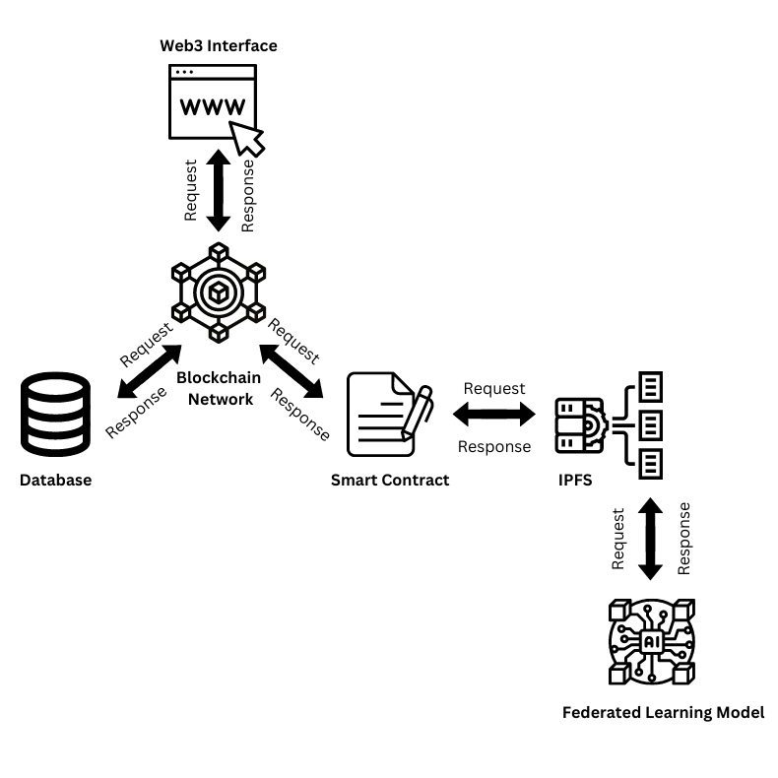

**High Level System Architecture**

## Software Architecture

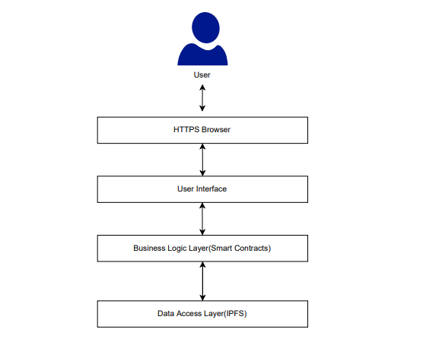

**Layered Software Architecture**

# **Design Strategy**

## Future System Extension or Enhancement

The system will be built using the latest edition of framework and encase a new update occurs in technology we must be ready. Stay updated by tracking orders with customized alerts and resolve issues proactively. Track real-time, Optimize routes and schedules and resource allocation in one centralized view.

## User Interface Paradigm

The user interface is very reliable and understandable to the user, the interface designed in such a way that mostly any expertise of people can easily learn and understand that what happens if I click this option, interface is very effective and efficient to increase the usability of users.

## Data Management

Main Data which are models will be stored on the IPFS and the relevant hashes of the model will be stored on smart contracts. Hospital will upload the model on web3 interface then store the model on the IPFS which will be use to apply federated leaning through aggregating of all these models.

# **Design Strategy**

## Database Design

**Not applicable (Database is being used to store data temporarily for authorization and registration purpose only, there are no other relations)**

## Application Design

## Sequence Diagram

#### 11.2.1.1<Sequence Diagram 1>

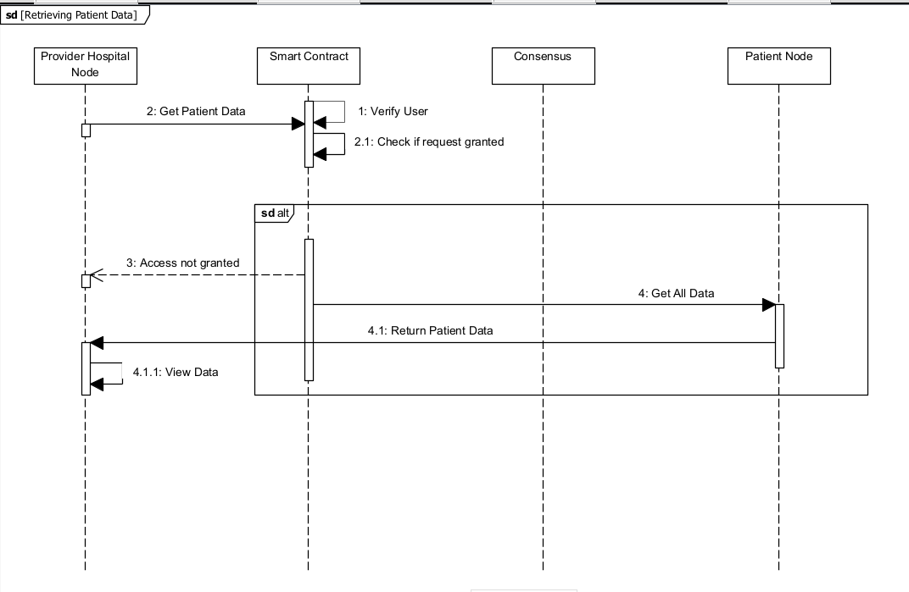

#### 11..2.1.2<Sequence Diagram 2>

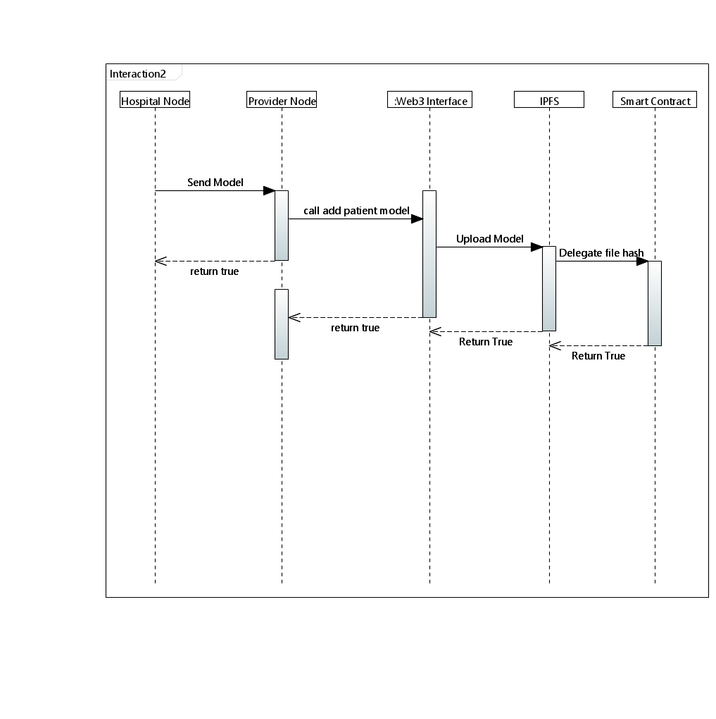

.

#### 11.2.1.3 <Sequence Diagram 3>

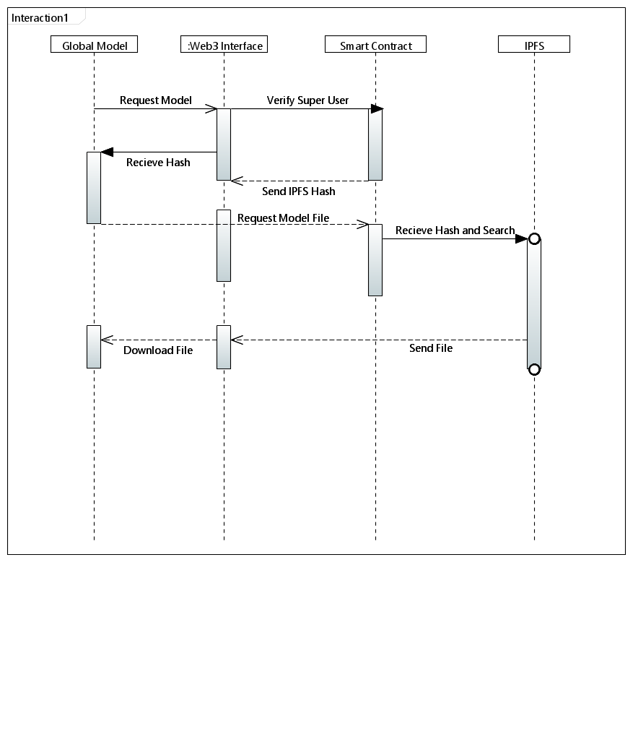

### 11.2.1.4<Sequence Diagram 4>

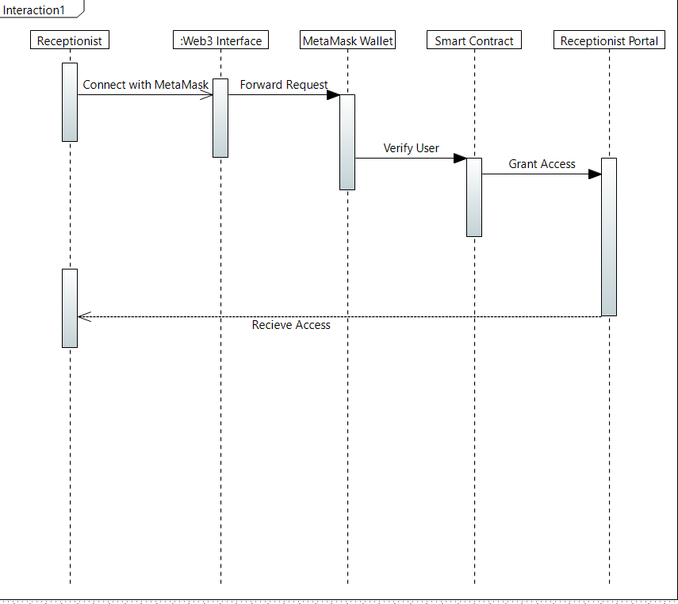

#### 11.2.1.5 <Sequence Diagram 5>

### Sequence_Diagram_1_Doctor_portal.drawio-1

## State Diagram

**11.2.2.1<State Diagram 1>**

**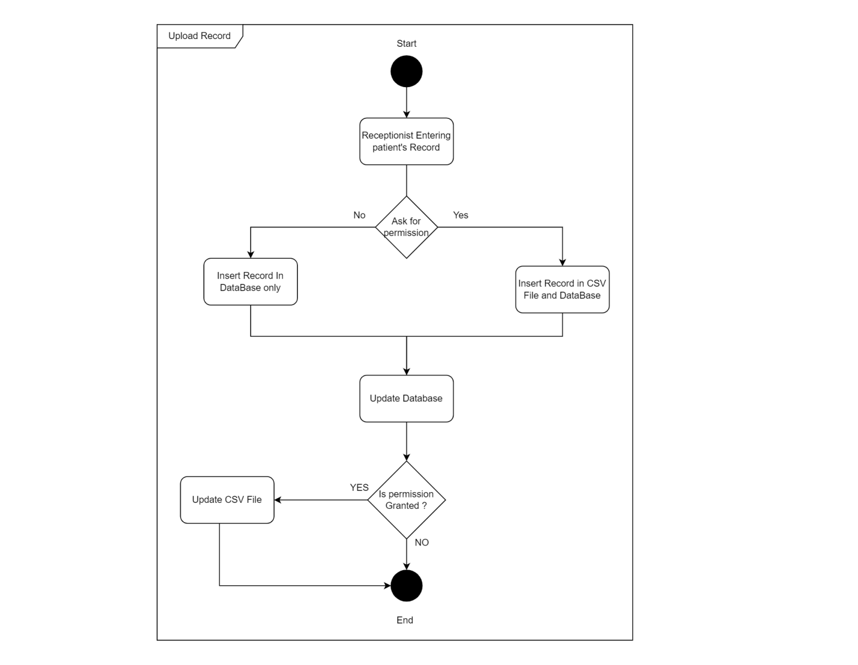**

**11.2.2.2<State Diagram 2>**

**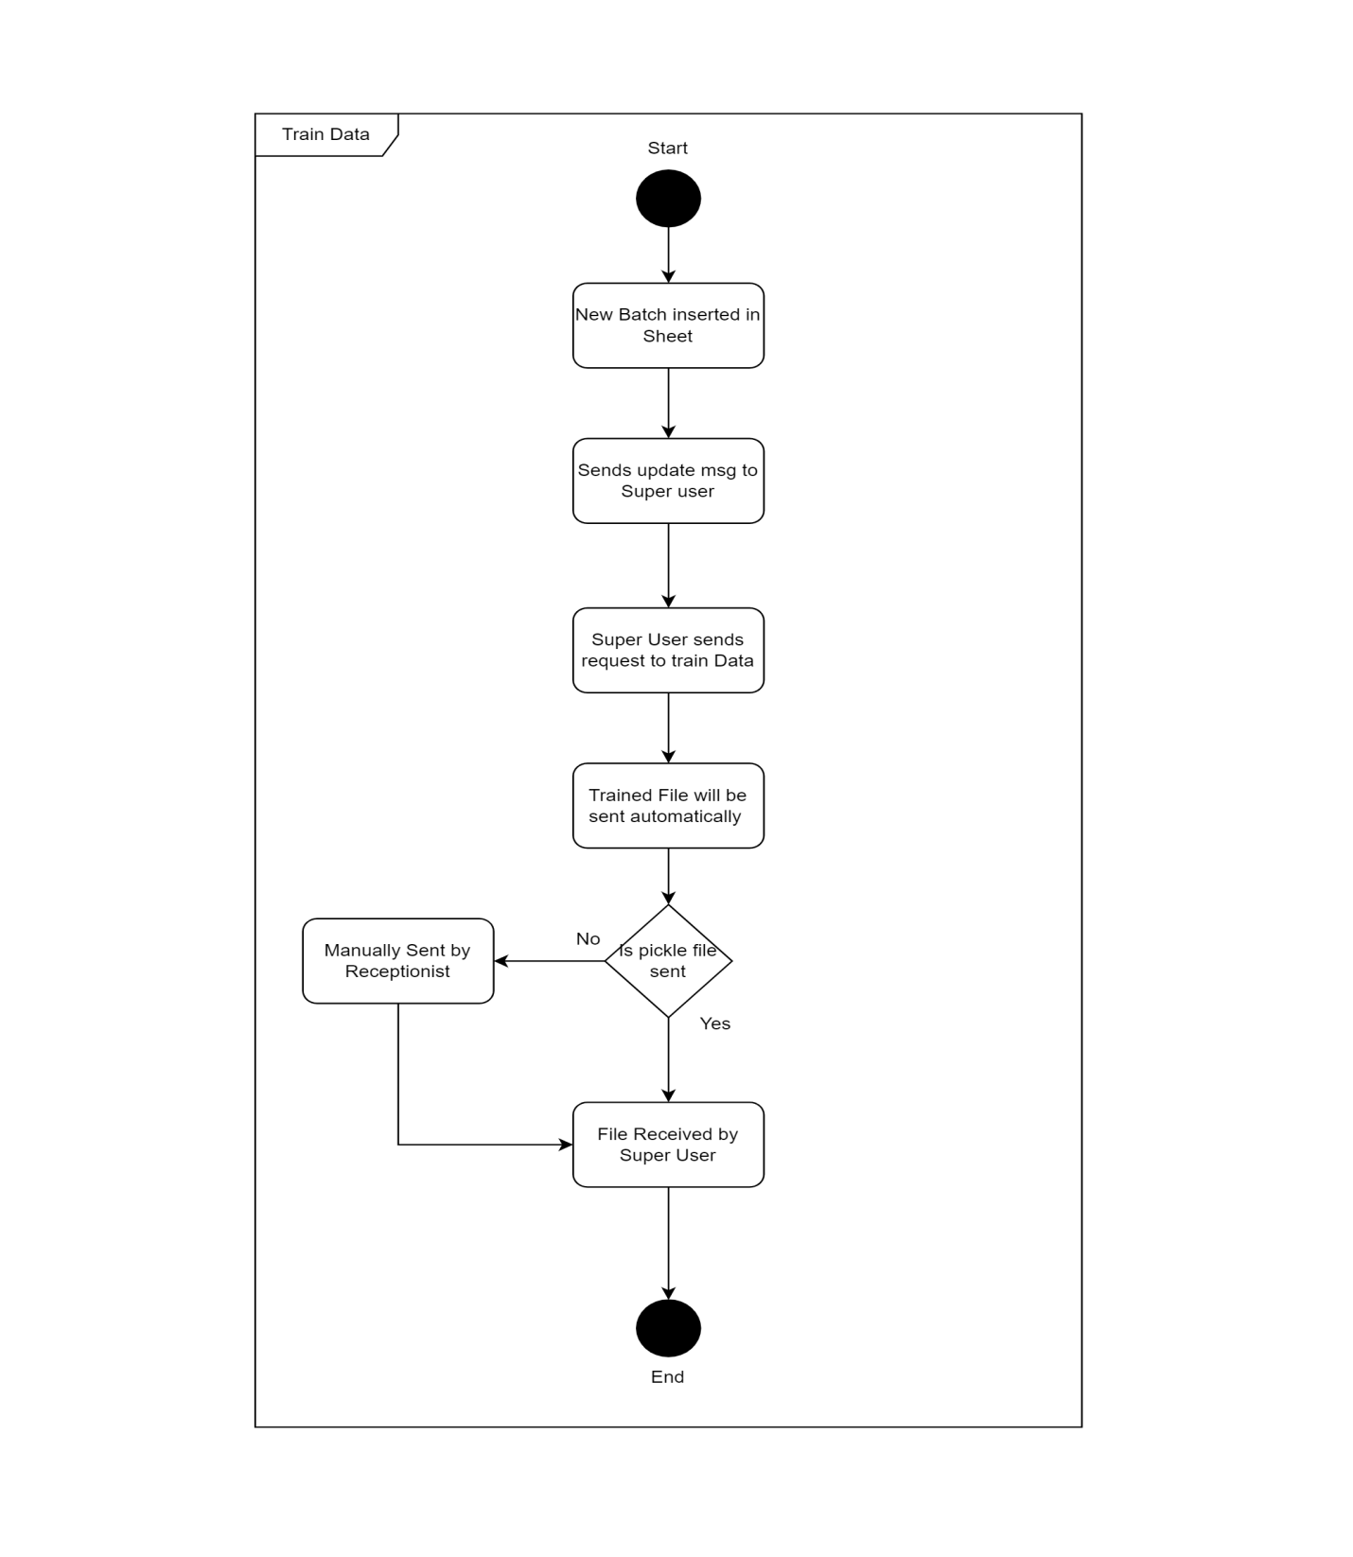**

References

*[This section should provide a complete list of all documents referenced at specific point in time. Each document should be identified by title, report number (if applicable), date, and publishing organization. Specify the sources from which the references can be obtained (This section is like the bibliography in a published book)].*

**11.2.2.3<State Diagram 3>**

# state 3

# Appendices

*[Include supporting detail that would be too distracting to include in the main body of the document.]*

**11.2.2.4<State Diagram 4>**

**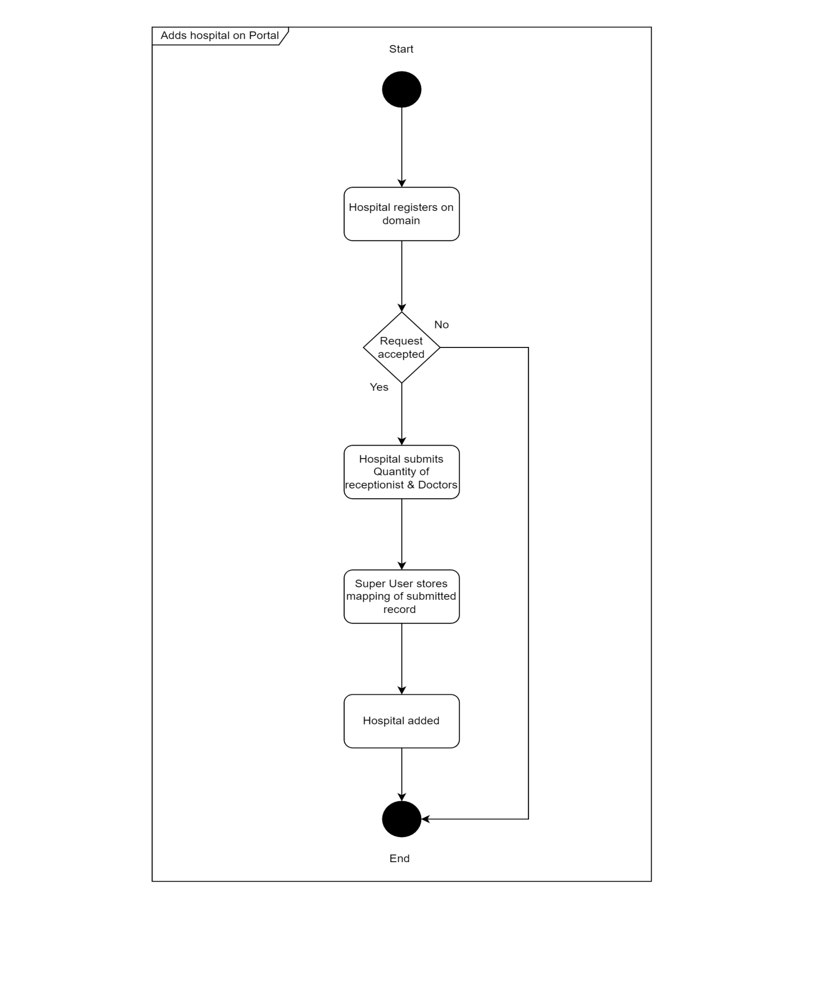**

# **References**

1. R. Roth, [M, Sheller](https://www.nature.com/articles/s41746-020-00323-1#auth-Micah-Sheller), “The future of digital health with federated

learning

”, September 2022, online: “<https://www.nature.com/articles/s41746-020-00323-1>”.

1. R. Stoffel et al,” Federated Learning for Healthcare: Systematic
2. Review and Architecture Proposal”, august 2022, online: ”<https://dl.acm.org/doi/10.1145/3501813>”
3. J.Xiu,C.Su,P.Walker, ”Federated Learning for Healthcare

Informatics”, November 2020, online: “[https://link.springer.com/article/10.1007/s41666-020-00082-4”](https://link.springer.com/article/10.1007/s41666-020-00082-4)